BCB Training

Little Mill High School and Middle School Training

Player Development & Habit Acquisition – *“Master The Boring”*

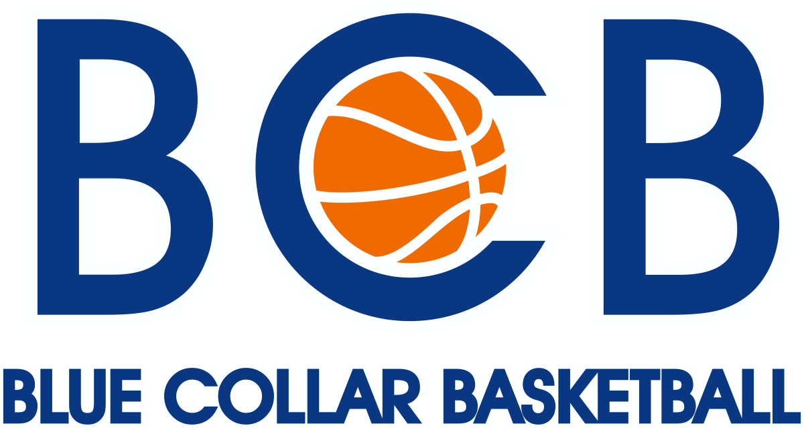

**“Direction & Discipline, not intention, determines our dreams & destiny”**

**Areas of Focus:**

1. Skill Development (measurement system that helps track progress)
2. Discipline
3. How to be a Special Teammate
4. Self-Awareness – Understanding where you are, where you want to be and how to “Close the Gap”
5. Competitive play
6. Defensive Principles: both on & off ball techniques and strategies

**Skill Development Specifics:**

1) Shooting: a) footwork b) follow-thru c) technique drills

2) Finishing Moves: a) finish both hands b) knowing the WHY & WHEN of finishes

3) Ball Handling: Ability to dribble and pass with both hands

4) Decision Making: Understanding when to use the skills

**Middle School Training Info:**

Location: Little Mill MS

Dates: Wednesdays

Times: 6:00-7:30[m

Who for: any rising MS or current MS level players

Cost: $15 per athlete per session, payment required up front. If need payment plan, we can work with you to determine that.

**High School Training Info**

Location: Little Mill MS

Dates: Mondays

Times: 6:00-7:30pm

Who for: any rising HS or current HS level players

Cost: $15 per athlete per session, payment required up front. If need payment plan, we can work with you to determine that.

RSVP: Email Beth Gliatta – [Bgliatta@forsyth.k12.ga.us](mailto:Bgliatta@forsyth.k12.ga.us)

Payment Info: Checks can be made out to “Blue Collar Basketball” or via PayPal ([bluecollarbball@gmail.com](mailto:bluecollarbball@gmail.com))

Registration Links:

High School Athletes- [https://app.upperhand.io/customers/194-blue-collar-basketball/events/8309-little-mill-middle-school-training-link](https://app.upperhand.io/customers/194-blue-collar-basketball/events/8309-little-mill-middle-school-training-link" \t "_blank)

Middle School Athletes-[https://app.upperhand.io/customers/194-blue-collar-basketball/events/8310-little-mill-high-school-training-link](https://app.upperhand.io/customers/194-blue-collar-basketball/events/8310-little-mill-high-school-training-link" \t "_blank)

Payment Questions: Training Questions: Email: sarahabcb@gmail.com

Sarah Allen Sam Allen Email: bluecollarbball@gmail.com

Phone: 706-766-6635 770-364-2889