TRAVEL INSTRUCTIONS

INSTRUCTIONS & HELPFUL TIPS FOR COMPLETING THE FORSYTH COUNTY SCHOOLS EMPLOYEE TRAVEL EXPENSE FORM

GENERAL PROVISIONS

|  |  |
| --- | --- |
| A close-up of a document  Description automatically generated  TRAVEL POLICIES & PROCEDURES  Forsyth County Schools reimburses travelers for reasonable and necessary expenditures incurred in connection with approved travel on its behalf.  The School District is required to follow the Statewide Travel Policy, as established by the State of Georgia. Forsyth County Schools also has additional provisions and requirements over travel to safeguard school district resources.  This instruction set is intended to assist school district employees with completing the travel expense statement to receive reimbursement for their travel expenses. While this instruction set does provide a limited view of the most common policies and procedures applicable to travel, all employees are still responsible for understanding and adhering to the State Travel Policy and all Forsyth County Schools policies and procedures. | This form is mainly concerned with  assisting employees in requesting reimbursement for their expenses. To assist employees with determining allowable travel expenses, and to provide employees with a guide to policies and procedures for travel, the school district has prepared a comprehensive travel procedure guide, available on the District website. The policy highlights the portions of the state travel policy applicable to Forsyth County Schools and the additional travel procedures beyond the state travel policy that are required by Forsyth County Schools. The travel procedures guide may be found on the school district’s website:  https://www.forsyth.k12.ga.us  Questions regarding these instructions, the travel expense statement, or travel policies and procedures may be directed to the finance department, located at the central office. |

GETTING REIMBURSED

|  |  |
| --- | --- |
| HELPFUL TIP  **ENSURE THAT YOU SUBMIT YOUR TRAVEL TIMELY**  **Travelers on an overnight/out of state trip should submit all expenses for reimbursement and reconciliation within 10 days of the completion of the event or trip but no longer than 45 days. If expenses are not submitted within the time frame, reimbursements will be denied.**  **All other travel not related to overnight/out of state trips should be submitted monthly. If these expenses are not submitted within the time frame, reimbursements will be denied as well.**  In order to ensure that you receive payment without being denied or taxed, **travel is due to the Finance Department three days prior to check issue dates. Checks are issued on the 12th and 25th of each month.** | HOW DO I GET REIMBURSED?  EMPLOYEE TRAVEL  Employee travel is conducted on a reimbursement basis in accordance with state policies. As an employee, you will need to travel in an official business capacity for the school district, and then request that the school district reimburse you.  All employees are required to fill out a travel expense statement once they have completed their travel on school district business. The form is then submitted to the individual who handles travel for your department or school. For schools, please submit to your school bookkeeper. For departments, please submit to your immediate supervisor. The latest version of the travel expense statement may be found at the following location:  https://www.forsyth.k12.ga.us  SUPERVISOR APPROVAL  Once you have submitted your form, it is checked by the individual who handles travel at your school or department and is then approved and signed by your supervisor or principal.  CENTRAL OFFICE  Once approved, the form is sent to the central office, where it is checked for accuracy. The form is checked by the AP Specialist and Finance Director prior to payment. Travel is reimbursed by check and sent through county mail to your primary work location. |

GETTING STARTED WITH THE TRAVEL FORM

|  |  |
| --- | --- |
| ENTER YOUR BASIC INFORMATION  To begin filling out your expense claim for your travel, you will first need to enter some basic information that will allow us to identify you and enter your claim into the accounting system.  You will need to provide your name, social security number or your Forsyth County Schools employee identification number, primary work location (headquarters), your address, and your license plate number.  If you used more than one vehicle when travelling, please note that you used more than one vehicle, the license tag of the additional vehicle, and which dates you used which vehicle. | GENERAL REQUIREMENTS  ONLY SUBMIT BUSINESS RELATED EXPENSES  When entering travel on the expense report, be sure to only include travel you made on behalf of Forsyth County Schools. Forsyth County Schools will not reimburse travel expenses that are not in relation to official school district business. If mixing personal travel with business travel, be sure to only claim travel related to the business part of your trip.  Example: Many training sessions are at locations outside the county. You may be at a training session at Jekyll Island from Monday through Thursday of a given week and may decide to stay an additional day at Jekyll Island for personal enjoyment. Your mileage and hotel expenses for the additional day would not be eligible for reimbursement by the District, because they are of a personal nature. Only the expenses for Monday through Thursday would be eligible for reimbursement.  STATE REPORTING  Be aware that, as part of the Georgia Open Records Act, your total travel expenses for the year will be uploaded to the State at year end for publication on the Open Georgia transparency website (<http://www.open.georgia.gov/>). All travel claims are also subject to audit by the Ga. Dept. of Education and the Ga. Dept. of Audits and Accounts annually. |

|  |  |
| --- | --- |
| HOW DO I REPORT MY MILEAGE?  TRACK YOUR ODOMETER READING  When travelling, take note of your odometer reading at the beginning and end of your journey. When filling out the travel expense statement, enter the date of travel, point of origin and points visited, purpose of your travel, your odometer readings. **Be sure to list the starting destination, final destination, and all major stops made in between the beginning and final destination.** The form will automatically calculate your mileage. You will enter this amount on pg.1 column “I35” and it will automatically calculate your mileage at the appropriate state rate.    *Multiple Vehicle Example*  If more than one personal vehicle was used to incur mileage on official school district business, please indicate this on your form as the mileages for the two vehicles will differ.  As an example, Jane Doe’s family owns two vehicles. Jane travels to a conference on June 1st and returns June 4th using one vehicle. One the 5th, she travels to another conference and returns on the 7th. The vehicle tag of the first vehicle is ABC 123 and the tag on the second vehicle is XYZ 789. | On her travel expense statement, Jane would separately report each day she was away in the “Date of Travel” column, so, in the first line, she would report June 1st, and in the 2nd line, she would report June 2nd, and so forth, through June 7th for a total of seven lines. Beside purpose of trip, she would indicate the license plate of each vehicle and which days she used each vehicle.  HELPFUL TIPS  If you frequently have trouble remembering your odometer reading or think you will forget, take a picture of your odometer reading with your phone at the beginning of your trip and at the end. Then you won’t have to worry about remembering it.  If you forgot to take an odometer reading during your trip, use an online map service like Google Maps to determine the mileage you travelled. Use your most recent odometer reading and subtract the distance indicated on the map service to obtain your beginning odometer reading. |

|  |  |
| --- | --- |
| BE SURE YOUR DESCRIPTIONS ARE  UNDERSTANDABLE  When entering your destination, ensure that someone can reasonably understand where you are going to and coming from. Any description needs to be identifiable by someone who is not familiar with your travel. Abbreviations, such as school abbreviations, may be used in lieu of the full address since these can be easily determined.  Some common examples for entering your mileage are shown in the figure below.  Note that an address is used in the final example below. This is the address of a conference location. Destinations which are not part of the Forsyth County School System should be listed by their address. “To the Hotel” or “To the conference” does not provide enough information to verify your mileage within the system. Inadequate descriptions could delay the processing of your travel. | See the source image  HELPFUL TIP  Using school abbreviations:  Big Creek Elem-BCE  Mashburn Elem-Mash  North High-NFHS  Settles Bridge Elem-SBE  County Office- CO  An example may be seen in the figure below. |

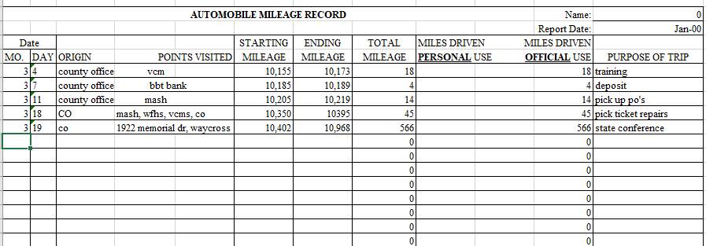

|  |  |
| --- | --- |
| HOW DO I CLAIM FARES ON MY FORM?  Fares include any school business related transportation expenses outside of mileage with your personal vehicle. Fares include airline tickets, train tickets, taxi fares, ferry tickets, ride-share expenses, such as Uber or Lyft, and even rental car expenses.  Enter fares incurred during your travel into the “Common Carrier” section of the travel expense form corresponding to the day of travel/payment. Ensure that a receipt is attached to your expense statement for any fares paid during the course of travel.  TAXES, UPGRAGES, & ADDITIONAL FEES  Certain taxes imposed on airline tickets and fares should be included in your expense claim form. Federal transportation taxes listed on airline tickets, sales or other taxes levied in other states (If travelling out of state), or sales taxes levied by local governments in the State should not be excluded.  These items should be included on your expense statement. However, the District does not reimburse for additional fees not part of the basic tickets or fares. Examples include priority boarding fees for airlines. The District will reimburse airline baggage fees for the first checked bag on a flight but will not reimburse for overweight bag fees or additional bags.  RENTAL VEHICLES  Rental cars should only be required for travel outside of the State of Georgia. **Approval from your supervisor is required before a rental car may be used as part of travel. Any rentals made without supervisor approval will be the responsibility of the employee.**  If a rental car is required, an economy, standard, or mid-size vehicle must be rented. The District will not reimburse for excessive costs. Vans may be rented if | if multiple employees are travelling to the same  destination and are choosing to carpool. Employees are encouraged to carpool, if possible and practical. If carpooling, the cost of a vehicle rental may be paid by and reimbursed to a single individual or multiple individuals. If the cost is being split between multiple people, indicate only your portion of the expense on your travel form and comment that you are claiming only your portion of the rental vehicle and note the other individuals you are splitting the cost with.  **Ensure all participating individuals attach a copy of the receipt with their expense form.**    HELPFUL TIP  Often, airline tickets and rental cars are booked in advance to provide cost savings to the District. When booking airline tickets and rental car expenses in advance, if you pay for the cost in advance, request reimbursement at the time you made payment and not when you plan to travel.  Example: You are going to a conference on July 16th but purchased your airline ticket in March, submit your travel for the ticket in March to avoid having your travel be over 45 days old.  This also applies to registration fees for the conference. |

|  |  |
| --- | --- |
| SUBMITTING LODGING CLAIMS  Lodging expenses include any hotel or motel expenditures incurred when traveling overnight for the District.  Enter lodging expenses in the “Lodging” column and indicate which nights you stayed at the hotel or motel in the “Date of Travel” column. You must list departure and arrival time for both destination and return day. Please report the cost of the hotel stay on a per night basis on your travel expense claim form, so that any instances where individuals stayed extra days for personal pleasure can be separated from those on official school district business. Ensure that a lodging bill or statement is attached to your expense statement. | HOW TO CLAIM LODGING EXPENSES  UNDERSTANDING HOTEL TAX CHARGES  When you are filling out your travel expense statement, you may look at your hotel bill and notice multiple types of charges, particularly various types of taxes. The figure at left illustrates the most common types of taxes you are likely to see on your hotel bill. Be aware that these taxes may be labelled differently on your hotel bill.  Understanding these taxes and what is allowable is the key to determining what to claim on your expense statement for your lodging expense. The figures on the following page illustrate how you should claim the various taxes listed on your hotel bill.  *State Hotel/Motel Fee*  When reviewing your lodging bill, one tax you will likely notice is the state hotel/motel fee. This fee is a flat rate that is listed on all bills within the State of Georgia. The school district is not exempt from this tax, which means you should include this tax in your expense claim for lodging. |

## HOW TO CLAIM LODGING EXPENSES

UNDERSTANDING HOTEL TAX CHARGES CONT.

*State Sales Taxes*

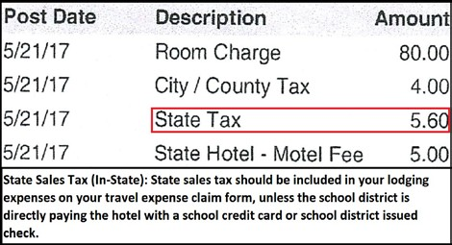State sales taxes are the standard sales taxes that the State imposes on all sales and transactions within its borders. Depending on the circumstances, you may or may not be able to include these expenses on your expense claim.

Under O.C.G.A. §48-8-3(1), lodging expenses are exempt from the State of Georgia Sales Tax when the payment method being used is a direct bill to Forsyth County Schools or a Forsyth County Schools credit card. If your lodging is being paid directly with a Forsyth County Schools credit card, the transaction is considered to be exempt from the State sales tax.

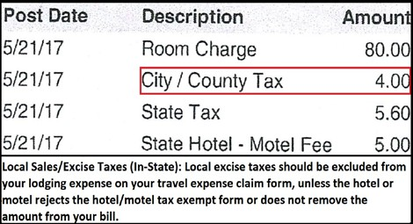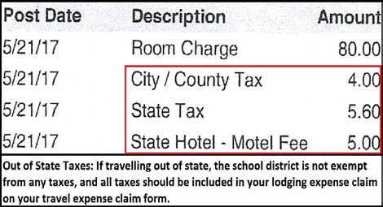**However, it is Forsyth County Schools policy that our credit cards are not to be used to pay for employees’ travel expenses**. Use of the credit card for payment of lodging prevents the expense from being reported on the State’s transparency site, which violates Georgia’s Open Records Act. However, on very rare occasions, such as student travel, the credit card may be used, as students are not employees of FCBOE and whose travel is not required to be reported on the State’s transparency website. **Prior permission from the Finance Office is required prior to any use of a county check or credit card for any form of travel.**

**As a result of the fact that Forsyth County credit cards cannot be used to pay for employees’ travel expenses**, you will likely use your personal credit card to pay for your lodging expenses at the time of travel. You should, therefore, include the state sales taxes on your expense claim.

|  |  |
| --- | --- |
| HOW TO CLAIM LODGING EXPENSES  UNDERSTANDING HOTEL TAX CHARGES CONT.  *Local Taxes*  Local taxes consist of the sales, occupancy, and excise taxes levied by local governments on lodging. Under O.C.G.A. 48-13-51(H)(3), state and local government officials, including school district personnel, are exempt from the county or municipal taxes on lodging. These expenses are typically removed from your bill when you present the hotel/motel tax exempt form to the hotel concierge upon check in.  To ensure that you are not charged inappropriately for taxes on your hotel bill, take a copy of the Hotel/Motel Tax Exempt Form and present it to the hotel concierge when you arrive. Ensure that you do not confuse the Hotel/Motel Tax Exempt Form with the ST-5 Sales Tax Exempt Form.  The Hotel/Motel Tax Exempt Form may be found on Forsyth County Schools’ website:  https://[www.forsyth.k12.ga.us](http://www.forsyth.k12.ga.us) | [Image result for picture of forsyth county board of education](https://www.bing.com/images/search?view=detailV2&ccid=7qZge8wq&id=3C0143D720E9C4A1DC3CADE3A686DF0E899FE3C9&thid=OIP.7qZge8wq3g5AdrfQHxGdpwHaEr&mediaurl=https://anvil-prod-forsythnews.s3.amazonaws.com/media/images/2017/06/22/images/FCS.max-752x423.jpg&exph=423&expw=669&q=picture+of+forsyth+county+board+of+education&simid=607994637081512157&selectedIndex=55)  The school district does not typically reimburse the local taxes charged on your hotel bill, as the hotel should remove the taxes when the tax- exempt form is presented. These expenses should not be included in the lodging expense claim on your travel expense claim form.  *Out-of-State Taxes*  When travelling outside the State of Georgia on behalf of the school district, lodging expenses are not exempt from taxes. You should include all taxes listed on your lodging bill in your lodging claim on the travel reimbursement form.  HELPFUL TIP  Often, hotels are booked in advance. When booking in advance, the hotel will not typically charge you for your lodging until you check-in. The hotel may temporarily “flash” your bank account when the reservation is made to ensure that your account has sufficient funds and that your banking information is correct.  However, if you are charged at the time of reservation and not check-in, submit your travel at the time of reservation to avoid having your travel be over 45 days old. |

|  |  |
| --- | --- |
| *Hotel Tax Charges Example Scenario* Jane Doe is a Forsyth County Schools employee who is travelling to the GAEL summer training conferences at Jekyll Island. Jane returns from the trip and begins completing her travel expense form to request reimbursement for her travel expenses. Jane sees the following expenses on her hotel bill:  ▪ Lodging: $100.00   * State Hotel/Motel Tax: $5.00 * County Occupancy Tax: $3.00 * State Sales Tax: $7.00   When Jane checked in at the hotel, she did not take a copy of the hotel/motel tax-exempt form with her, and forgot to present it to the concierge when she checked in. Jane also paid for the hotel expenses with her own personal account. The school district did not pay for her hotel in advance.  Jane should claim $112.00 ($100 + $5 + $7) as her lodging expenses on the travel claim form. She forgot to take the hotel/motel form and, as a result, is not eligible to request reimbursement for the county occupancy tax.  If Jane had taken the hotel/motel tax-exempt form, the hotel would have removed the  $3.00 local tax from her bill.  If she took the form, and the hotel still refused the form, Jane would claim $115.00 ($100 +  $5 + $3 + $7) and she would indicate on her travel expense statement that the hotel refused to take the hotel/motel tax exempt form. | LODGING EXPENSES THE DISTRICT  WILL NOT REIMBURSE  The school district will not reimburse travel expenditures that it deems to be excessive or an improper use of district funds. The district will not reimburse certain lodging expenditures which include but are not limited to:   * Valet Parking (Unless it is the only option available. If requesting reimbursement for valet parking, indicate on your form that this was the only option available) * Baggage Handling Services * Internet Usage Charges (Unless Business Related) * Alcoholic Beverages * Expenses related to vacation days taken before, during, or after a trip. * Clothing or Toiletry Items * Movies/Pay-Per-View * Other Costs or Expenses Not Listed Above That the District Deems Excessive or Wasteful   See the source image |

## SUBMITTING MEAL EXPENSES

When travelling on behalf of the school district, you may be away long enough that you need to claim one or more meals. Meal expenses should be entered in the corresponding “Breakfast, Lunch, and Dinner” columns on the travel expense claim form.

# PER DIEM

The school district, under the state travel policy, is allowed to reimburse meal expenses for each day of overnight travel, up to a state specified maximum limit. Typically, only employees engaged in overnight travel are eligible for per diem. Per diem can only be claimed for meals not provided to you by another source, such as a meal provided by a conference that was part of a registration fee.

**Typically, only overnight travelers are eligible to receive per diem. However, if school district employees travel more than 50 miles from their primary work location, and is away for 12 hours or more, they may claim meal expenses for the entire day, even if they do not stay overnight**.

Per diem is subject to a maximum cap by the State of Georgia. **Any expenses in excess of the maximum amount set by the State are the responsibility of the**

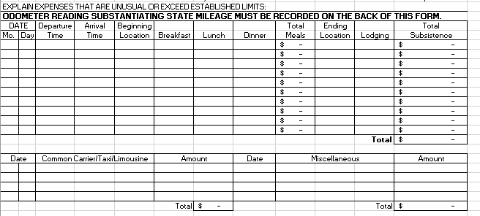

**employee**. When submitting your meal expenses on the form, you should claim either the amount you actually paid, as shown on the receipt, or the maximum per diem rate, whichever is less.

As an example, if Jane Doe travels overnight to Atlanta, and the per diem rate for dinner in Atlanta is $20, and Jane spends $25, then Jane would claim $20 on her travel form under the “Dinner” column, because the maximum allowed rate under state policy is $20. If the rate for dinner in Atlanta were $20, and Jane spent $10 on her meal for the evening, then Jane would claim $10 in the “Dinner” column on her travel expense statement.

**Increased In State Meal Per Diem Rates. Removed Georgia high-cost cities. Adjusted meal per diem rates for the state. The new rates are for all cities in Georgia.**

|  |  |
| --- | --- |
| The Standard In-State per diem rate: | |
| **Eligible Meals** | **Per Diem Amount** |
| Breakfast | $13.00 |
| Lunch | $14.00 |
| Dinner | $23.00 |

|  |  |
| --- | --- |
| SUBMITTING MEAL EXPENSES  *PROVIDED MEALS*  Under state travel regulations, the school district is not allowed to reimburse travelers for meals that are provided to them free of charge.  For example, if Jane Doe is attending a conference, and the conference automatically provides a meal to her or provides a meal without requirement for her to pay for it out of her pocket, she cannot claim reimbursement for that meal. If the meal was included as part of the registration fee, reimbursement for that meal would be included in her reimbursement when she claims the conference registration fee on her travel expense form.  If you have medical or dietary restrictions require that you make alternate arrangements for the provided meal, please indicate on your travel form that dietary restrictions prevent you from taking advantage of the provided meal and claim the expense for reimbursement on your travel expense form.  [Image result for picture of forsyth county board of education in georgia](https://www.bing.com/images/search?view=detailV2&ccid=NNymIJ8I&id=64C60D17823C205DF97D7AECB820D4ACD43344DA&thid=OIP.NNymIJ8Iad4NmUg97TPfnQHaFj&mediaurl=https://www.georgiaencyclopedia.org/sites/default/files/styles/article-top/public/m-10032.jpg?itok%3dkT24G8gP&exph=488&expw=650&q=picture+of+forsyth+county+board+of+education+in+georgia&simid=608042873868585172&selectedIndex=30) | See the source image  sit Academia Mexico  HELPFUL TIPS  Before you leave for your trip, obtain the travel expense statement and verify the most recent per diem rates. This will allow you to be aware of the maximum per diem rates for which you can be reimbursed during your trip.  If you are travelling out of state, contact the finance office, located at the central office, to determine per diem rates before departing.  Per diem expenses for each meal are defined on a per meal basis by the state travel regulations, so you cannot combine your per diem for the day and spend your per diem on a single meal. For example, you cannot save your daily allowance for breakfast and lunch to combine and spend on dinner. |

|  |  |
| --- | --- |
| SUBMITTING OTHER EXPENSES  Incidental expenditures include those expenditures that are the miscellaneous expenses incurred during travel on official business. Incidental or other expenses should be entered into the “Miscellaneous” column of the travel expense claim form. Ensure that a receipt or bill is included with any other expenses claimed, including conference registration fees.  WHAT CAN I CLAIM?  The most common miscellaneous expenses claimed by HCS personnel are:   * Parking fees, * Conference registration fees * Airline baggage fees (First bag only)   Conference registration fees should be included in the miscellaneous column only when paid by the employee and not by the district.  Registration fees for online conferences should not be run through travel, but through the regular P.O. or purchasing process.  A full, comprehensive list of allowable miscellaneous expenses for reimbursement may be found in the state travel regulations. | [Image result for pictures of lake lanier georgia](https://www.google.com/imgres?imgurl=http://www.boatrentalshq.com/wp-content/uploads/2014/07/Lake-Lanier.jpg&imgrefurl=http://www.boatrentalshq.com/lake-lanier/&docid=i3bqSwnCgkDrvM&tbnid=MeITCKD_zbtOrM:&vet=10ahUKEwjHo-CZzPzgAhURjoMKHdWYCWkQMwhlKBgwGA..i&w=1024&h=768&bih=624&biw=1242&q=pictures%20of%20lake%20lanier%20georgia&ved=0ahUKEwjHo-CZzPzgAhURjoMKHdWYCWkQMwhlKBgwGA&iact=mrc&uact=8)  WHAT AM I NOT ALLOWED TO CLAIM?  Non-reimbursable expenses include, but are not limited to:   * Airline, car, or card membership dues/fees * Alcoholic Beverages * Haircuts/Personal Grooming * Lost Baggage * Mini-Bar Charges * Movies * Clothing/Toiletry Items * Travel Upgrade Fees * Priority Seating Fees * Airline baggage fees beyond the first checked bag * Fees for excessive baggage weight * Laundry costs * Expenses related to vacation or personal days taken before, after, or during a trip. * Other Costs or Expenses Not Listed Above That the District Deems Excessive or Wasteful   A full, comprehensive list of non-reimbursable miscellaneous expenses may be found in the state travel. |