**Technology Apps**

*\*These are apps that will be beneficial for your*

*child to have downloaded on their technology device for BYOT*

**Free Reading Apps**

* [**Sight Words by Photo Touch**](http://itunes.apple.com/us/app/sight-words-by-photo-touch/id421341850?mt=8)**:** to practice and learn sight words by sight, sound, and touch
* **Raz-Kids-**practice reading on child’s reading level.
* [**Read on Sight**](http://itunes.apple.com/us/app/word-blocks/id434349833?mt=8): sentence practice app; the child hears the sentence, watches the words scatter, and then puts the words back into place.
* [**Sentence Magic**](http://itunes.apple.com/us/app/sentence-reading-magic/id454581599?mt=8): helps with basic sentence building and reading
* [**Futaba**](http://itunes.apple.com/us/app/word-games-for-kids-futaba/id426517722?mt=8): four player word and picture matching game that allows students to build and develop vocabulary
* [**Reading Monster Town**](http://itunes.apple.com/us/app/reading-monster-town-1/id463249368?mt=8): fiction and nonfiction passages with interactive word and sentence games, all based on the elementary curriculum
* [**MeeGenius!**](http://itunes.apple.com/us/app/meegenius%21-kids-books/id364734296?mt=8): a library of over 200 children's books with interaction that supports reading development (ex; word highlighting). *Some titles are free, and some are not.*
* [**Not the Hole Story**](http://itunes.apple.com/us/app/not-the-hole-story/id431455265?mt=8): incomplete stories that students have to use reading comprehension skills and creativity to finish
* [**Timed Reading Practice**](http://itunes.apple.com/us/app/k12-timed-reading-practice/id374985358?mt=8): practice reading fluency by reading short, time passages

**Free Word Work Apps**

* [**Tic Tac Toe Phonics**](http://itunes.apple.com/us/app/phonics-tic-tac-toe-interactive/id465184366?mt=8)**:** interactive tic tac toe game that practices vowel sounds, letter sounds, word parts, etc.
* [**ABC Phonics Rhyming Words Lite**](http://itunes.apple.com/us/app/abc-phonics-rhyming-words/id437201718?mt=8)**:** fun rhyming game for children to learn and practice phonics by finding pairs of matching words
* [**abc Pocket Phonics**](http://itunes.apple.com/us/app/abc-pocketphonics-lite-letter/id302689971?mt=8)**:** practice hearing, saying, and writing letter sounds and basic sight words
* [**Build A Word Express**](http://itunes.apple.com/us/app/build-a-word-express-practice/id445774924?mt=8)**:** practice spelling and word building by using letters, letter sounds, or letter names
* [**Letter Bug**](http://itunes.apple.com/us/app/free-letter-bug/id329509834?mt=8)**:** fast-paced game that allows students to practice letters and spelling
* [**Beginning Sounds Sorting Game**](http://itunes.apple.com/om/app/beginning-sounds-interactive/id465479183?mt=8)**:** interactive game in which kids can match words and pictures with the same beginning sounds, including letters, blends, etc
* [**Bluster! by McGraw Hill**](http://itunes.apple.com/us/app/bluster%21/id416160693?mt=8)**:** word matching game that helps with vocabulary development; work on synonyms, rhyming words, prefixes and suffixes, adjectives, root words, and homophones
* [**Vowel Lite**](http://itunes.apple.com/us/app/howie-finding-vowel-lite/id463956443?mt=8)**:** vowel game that uses phonics to help children learn new words as they listen to sounds and build words

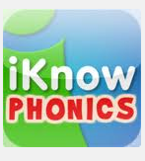 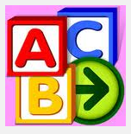 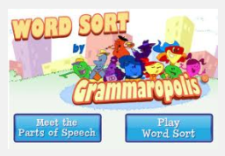 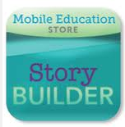

**iKnow Phonics Starfall Grammaropolis Story Builder**

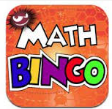 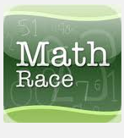 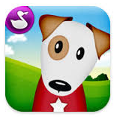  

**Math BINGO Math Race Pop Math Make 10 Plus Teaching Number Lines**